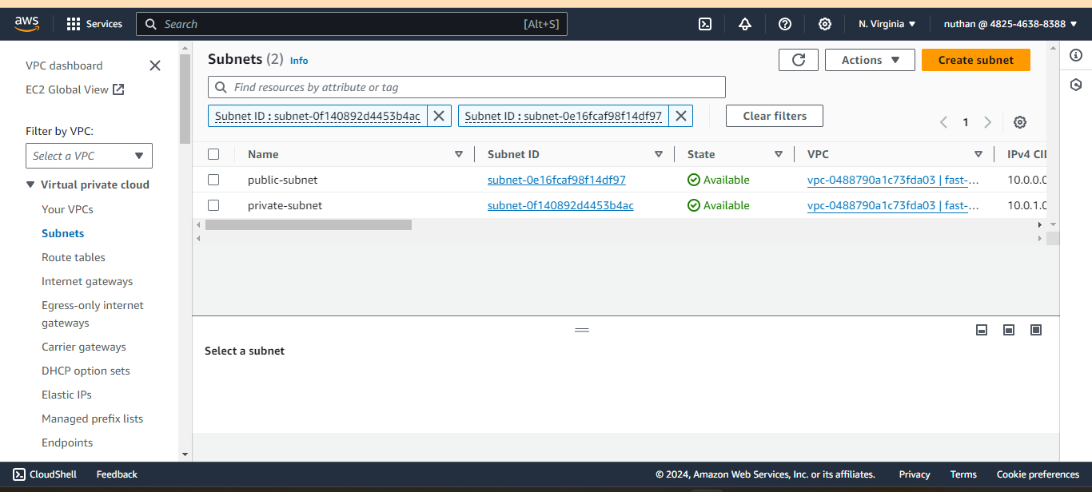Fig-1 : created private and public subnets with in fast-tech-solutions VPC

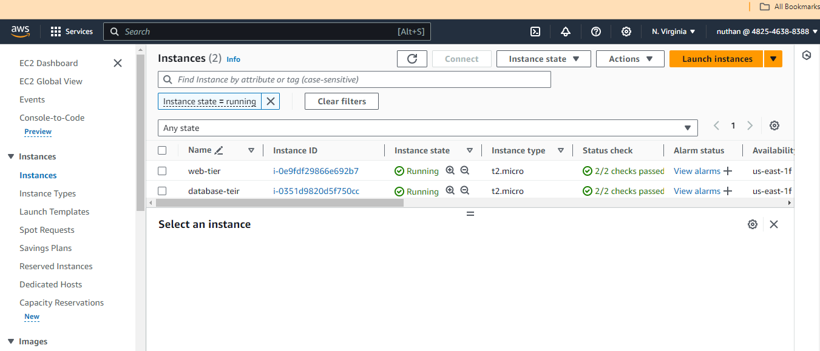

Fig-2 : Created web-tier and database-tier instances

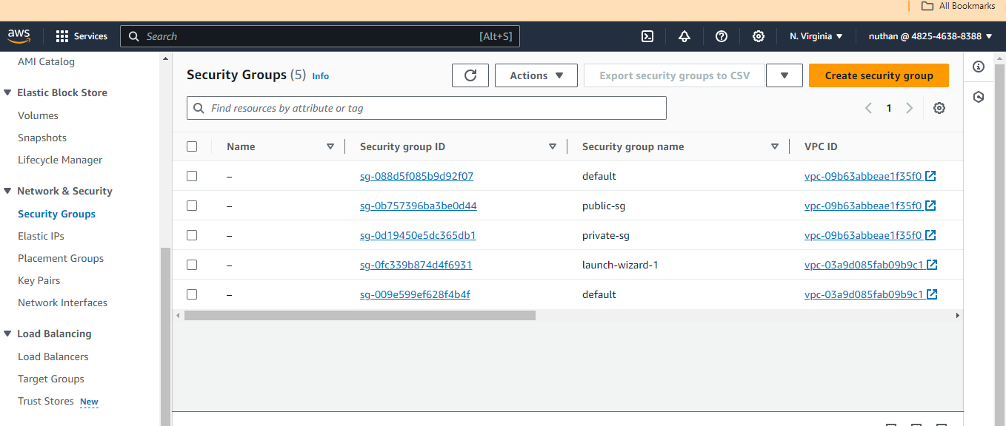

Fig-3 : created public security group and private sg for respected instances

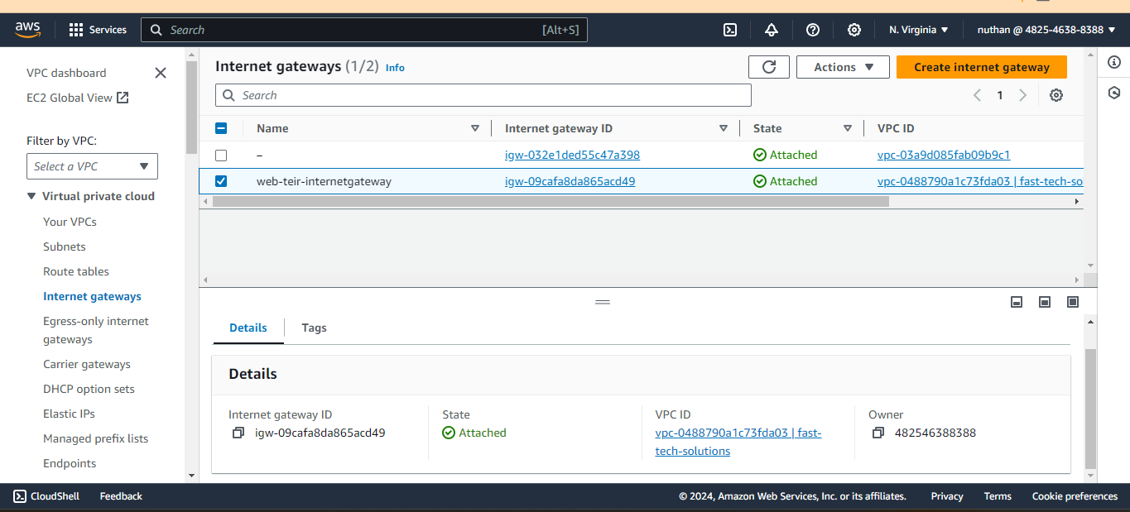

Fig-4 : created Internet gateway to provide internet to public instance web- tier

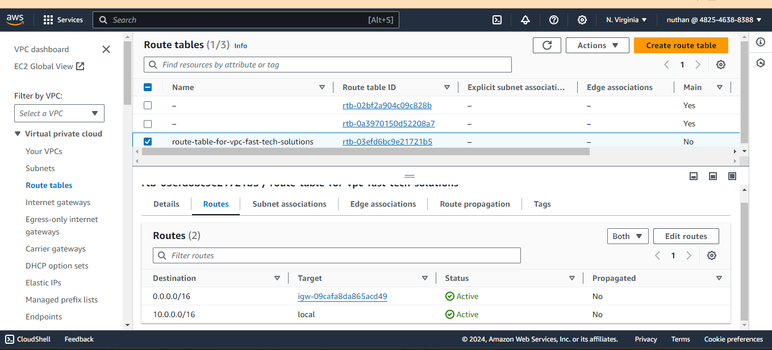

Fig-5 : Created route-table and configured routes to get access internet by public instance

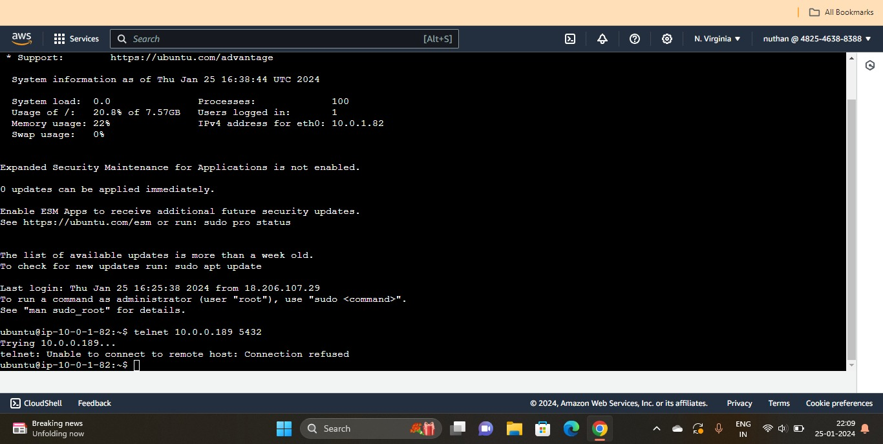

Fig -6: telnet connection refused (required output for mini_project)